September 6, 2018

The Honorable Robert E. Lighthizer
Ambassador
Office of the United States Trade Representative
600 17th Street NW
Washington, DC 20006

RE: Notice of Action and Request for Public Comment Concerning Proposed Determination of Action Pursuant to Section 301: China’s Acts, Policies, and Practices Related to Technology Transfer, Intellectual Property, and Innovation (Docket No. USTR-2018-0026)

Dear Ambassador Lighthizer:

On behalf of Walmart, thank you for the opportunity to comment on the Notice of Proposed Determination of Action Pursuant to Section 301: China’s Acts, Policies, and Practices Related to Technology Transfer, Intellectual Property, and Innovation (Notice of Proposed Action) (Docket No. USTR-2018-0026) issued by the Office of the United States Trade Representative (USTR) on July 17, 2018. Per the Federal Register notice, we focus our comments below on the economic harm associated with the proposed duties for U.S. manufacturers, consumers and exporters. We also discuss the challenges associated with restructuring supply chains to offset the increased duties.

Walmart helps people around the world save money and live better - anytime and anywhere - in retail stores, online, and through their mobile devices. Each week, nearly 265 million customers and members visit our more than 11,200 stores under 55 banners in 27 countries and eCommerce websites. With fiscal year 2018 revenue of $500.3 billion, Walmart employs more than 2.2 million associates worldwide. Walmart continues to be a leader in sustainability, corporate philanthropy and employment opportunity.

As the largest retailer in the United States and a major buyer of U.S. manufactured goods, we are very concerned about the impacts these tariffs would have on our business, our customers, our suppliers and the U.S. economy as a whole. This round of tariffs could impact a significant number of common consumer items that are not easily replaceable. A non-exhaustive summary of consumer products on the proposed list include a range of food products (fish, vegetables, nuts, fruit, grains, flours, other products like soy sauce); beverages; personal care products (makeup to shampoos); detergents; motor vehicles, motorcycles and bicycles; travel goods, handbags and other bags; leather apparel; paper office supplies; hats; hand tools; furniture; lighting and mirrors, including Christmas lights; monitors; paper tablecloths, napkins, plates and cups, toilet and tissue paper, dog leashes, home air conditioners, refrigerators, vacuum cleaners, calculators, baby products and many others. The immediate impact will be to raise prices on consumers and tax American business and manufacturers. Below we highlight key areas of concern and specific products we hope will be removed from the 301 tariff list. We welcome the opportunity to discuss our comments further, as we believe making these changes will meaningfully benefit U.S. manufacturers, consumers, and the economy.

Impact on U.S. Manufacturers
Around the world, Walmart purchases the majority of the merchandise we sell locally in the country where our stores and eCommerce businesses operate. According to data provided by our suppliers, two-thirds of what Walmart spends on products sold in our U.S. stores is sourced, assembled or grown in the United States. In January 2013, Walmart furthered its commitment to American economic renewal by announcing a 10-year commitment to purchase an additional $250 billion in products that support American jobs. We are proud that this effort is already having a tangible impact in communities across America.

Unfortunately, the proposed tariffs have the potential to undermine these reshoring initiatives. Many manufactures rely on component parts from China to assemble and finish production in the United States. Yet, the list includes component parts essential in the manufacture of fans, televisions, bicycles, cameras, radio receivers, electronics and connected home products. We have heard from U.S. manufacturers from all across the country that the tariffs on component parts will negatively affect their competiveness and employment in the United Sates. For example, fans assembled in the United States by our supplier Lasko in manufacturing facilities in Texas and Tennessee rely on motors and other parts imported from China. Tariffs on intermediate goods make little sense when the stated goal of the Administration is to increase manufacturing and jobs in the United States.

Tariffs on bicycles and bicycle parts will negatively impact bicycle manufacturers and consumers. Each mass market bicycle requires over 40 individual parts, all of which are imported. Tariffs on these parts would make U.S. manufacturing uncompetitive and drive up the price of bicycles for children and families across the United States. Complete bicycles are already subject to an 11 percent tariff. Adding an additional 25 percent, will increase cost and reduce demand for bikes, and will also affect downstream purchases for products such helmets, lights, tubes, tires, and bags.

Consumers in the U.S. purchase approximately 14 million bicycles annually. Although Walmart has been working to enhance sourcing from U.S. manufacturers, there is simply not enough current U.S. production to meet demand in the United States. And, while production could shift at the margins, sourcing most entry-level mass bicycles from China would likely still be less expensive than shifting production, even with an additional 25 percent duty. Alternatively, we expect that even if portions of bicycle production were to shift to other countries, the vast majority of component parts would continue to be made in China. Finally, bicycles produced for the mass market are a low-technology, high-volume enterprise. They do not involve the types of sensitive intellectual property or innovative technology that are the primary concern of the Section 301 investigation.

Impact on Customers
The current list of $200 billion in imports proposes an additional 10 to 25% duties on a range of consumer products, driving up costs for households who rely on these products to meet their daily needs. Should the tariffs go into effect, Walmart customers will face cost increases for essential items like car seats, cribs, backpacks, hats, pet products and bicycles. For lower-income families, a 25% tax on these items would be a serious burden on household finances. Walmart and our suppliers will pay the cost of increased duties, which are simply taxes levied on products at the border. As a result, either consumers will pay more, suppliers will receive less, retail margins will be lower, or consumers will buy fewer products or forego purchases altogether. Furthermore, none of these items are related to intellectual property or trade secrets and it is difficult to see how taxing these good will resolve these more complex trade challenges.

A recent National Retail Federation study predicts that new tariffs will cost consumers billions of dollars on purchases of furniture and travel goods alone. The report indicates that the proposed duties on furniture would cost Americans $4.5 billion per year, even if manufacturers shifted to alternate countries for manufacturing. A similar 25% on travel items like luggage and handbags would add $1.2 billion to what consumers currently pay.

Priority Products
Below please find a list of priority products (with emphasis added for those of most importance) for Walmart in terms of volume, availability and challenges associated with alternate sourcing. Also attached is a complete list of HTS codes for consumer products that could be affected by these tariffs. Walmart would also like to associate ourselves with the comments and submissions of Retail Industry Leaders Association and National Retail Federation which outline the detrimental impact of the proposed tariffs on the retail sector as a whole.

HTS | Description
2008.30.48 | Mandarin oranges in cans
2309.10.00 | Rawhide for pets
3305.90.00 | Hair care
3307.90.00 | Other bath prep
4201.00.30 | Dog leashes, dog collars
4201.00.60 | Cat leashes, pet costumes
4202.12.21 | Hard luggage
4202.12.81 | Luggage, tote bags, duffle bags, handbags
4202.22.15 | Travel bags, handbags
4202.22.45/81 | Handbags
4202.92.31 | Backpacks
4810.99.10 | Rolled wrapping paper
4811.90.80 | Rolled wrapping paper
7321.11.60 | Gas grills
7009.92.10 | Make up mirrors
8508.11.00 | Vacuum cleaners
8509.90.55 | Toothbrush replacement heads
8510.90.10 | Electric razors
8415.10.30 | Air conditioners
8544.42.20 | HDMI cables, video cables, extension cords, auxiliary cords
8516.60.40 | Oil less fryers and toaster ovens
8517.62.00 | Connected home: modem, router, e-readers, thermostats, wireless headphones, smart watches, fitness trackers
8712.00.15 | Bicycles
9401.40.00 | Futons
9401.61.40 | Toddler seats
9401.79.00 | Child High Chairs
9401.80.40 | Patio furniture
9401.80.60 | Infant and Child Car Seats
9403.60.80 | Wooden Furniture
9403.89.60 | Infant and child pack and play, patio furniture
9494.21.99 | Mattresses
9405.30.00 | Christmas Lights
9405.40.84 | Christmas Lights

Challenges Associated with Alternate Sources of Supply

For many of the products on the USTR list, shifting production to new facilities outside of China is not a viable option.

Safety Issues
Walmart is particularly concerned about the numerous juvenile products (cribs, car seats, hygiene products, feeding products, safe sleep products and strollers) that could be subject to new tariffs. Juvenile products are required under U.S. law to be premarket tested and certified as meeting an extensive array of U.S. safety requirements and are intensely regulated by U.S. federal government agencies such as the Consumer Product Safety Commission and the National Highway Transportation Safety Administration. Any change in supplier, whether finished product, component materials or sub-materials would require new testing and certification. According to the Juvenile Products Manufacturers Association, it is simply not feasible to shift production to different countries or facilities without compromising contracts, legal compliance, quality and value for the customer.

In addition, increased costs associated with new tariffs could lead families to turn to cheaper, but less safe options to offset new financial burdens. New parents may look to the secondhand market for used car seats and other baby products, and thereby sacrifice the newest safety features or unknowingly purchase a product under recall.

Similar safety, certification and compliance concerns exist for other regulated products from cosmetics and hair care to small appliances. For personal care products, for example, it takes significant time and resources to ensure that a potential supplier can meet these requirements, including the FDA's good manufacturing practices (GMPs). Global supply chains are complex, particularly where safety standards are involved, and it takes time to find the right partners who meet the appropriate criteria.

Complexity of Supply Chains
For many of the products on the tariff list, China is the sole or primary source of U.S. imports. It is not practicable to consider shifting production outside of China for the bulk of these products. For example, new suppliers must meet a variety of requirements related to tooling and sourcing of raw materials including testing, regulatory and social compliance, in addition to safety approvals. Establishing new facilities would not only take time, but could drive up cost as suppliers lose economies of scale and vertically integrated production in China.

Impact on U.S. Exporters
As a global retailer, Walmart is proud to serve as an export gateway for U.S. products into international markets. Our retail and e-commerce platforms have, for many years, supplied a variety of U.S. products to Chinese consumers. For example, our Sam’s Club in Beijing was the first physical retailer to sell U.S. beef after the market re-opened last year. We started with choice-grade short ribs from Nebraska and delivered them using a 30-hour cold chain mechanism. Walmart China also sells U.S. pork, beef, cherries, nuts wine, apples, cheese and milk in addition to a variety of U.S. origin consumer products. Unfortunately, many of these products are now facing retaliatory duties in response to U.S. tariffs. For example, cherry producers are now subject to 50% duties on their products and have reported lost sales and lower margins as a result. We are similarly worried about our pork, beef, nut and wine suppliers who are also targets of retaliation. The pressure on these U.S. exporters is amplified by new, retaliatory tariffs they are facing from other trading partners such as Canada, Mexico, and the European Union.

Conclusion
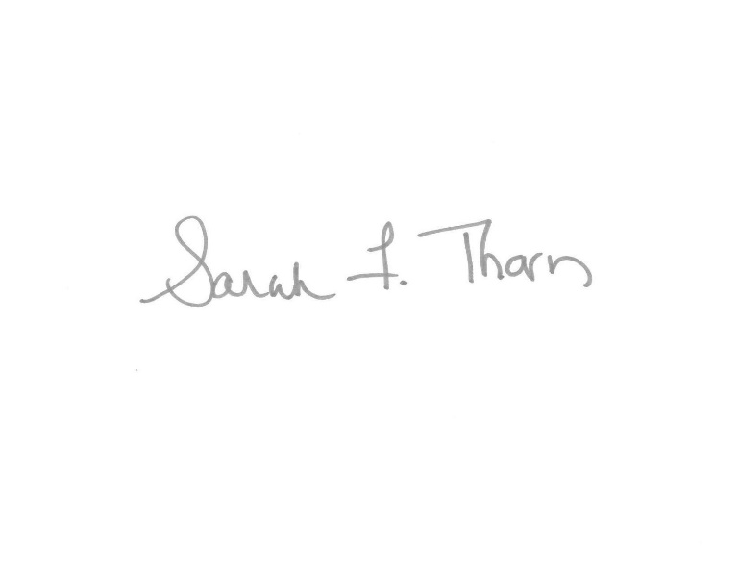
As a global retailer, Walmart is very concerned about the disruptive impact of these proposed tariffs on our customers and suppliers both in the United States and China. This year has seen strong momentum in the U.S. economy, momentum that we hope can be maintained to the benefit of U.S. workers and business. We urge against the imposition of any additional duties and request that the Administration instead pursue a negotiated settlement to the specific concerns raised in the Section 301 Investigation. We welcome the opportunity for further dialogue with the Administration on tariffs associated with the 301 investigation.

Sincerely,

Sarah F. Thorn

